LIST

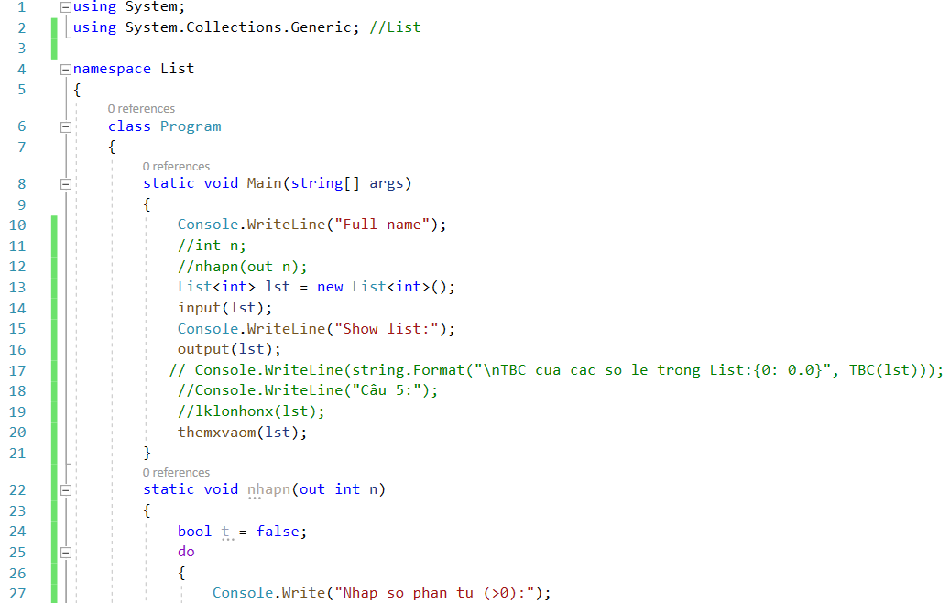

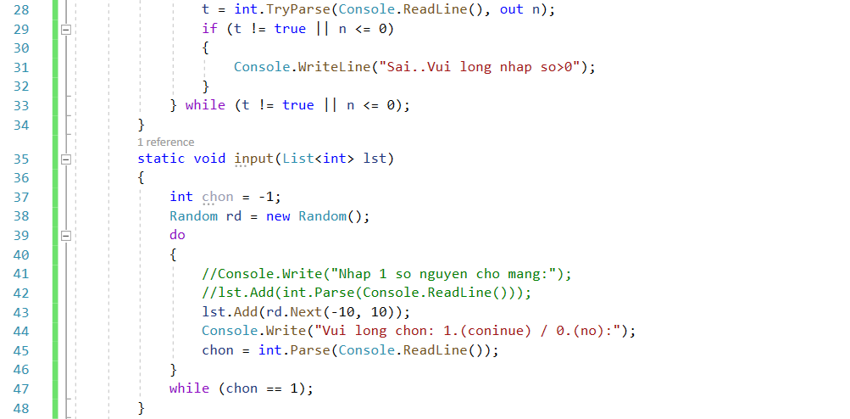

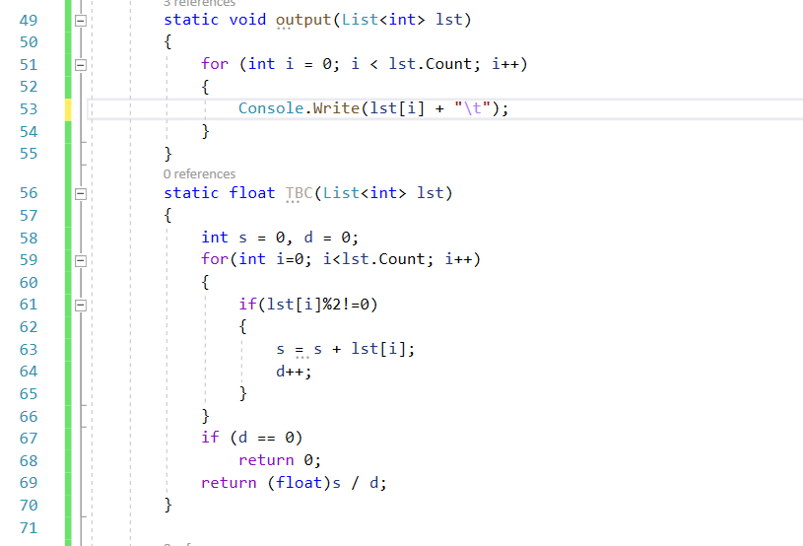

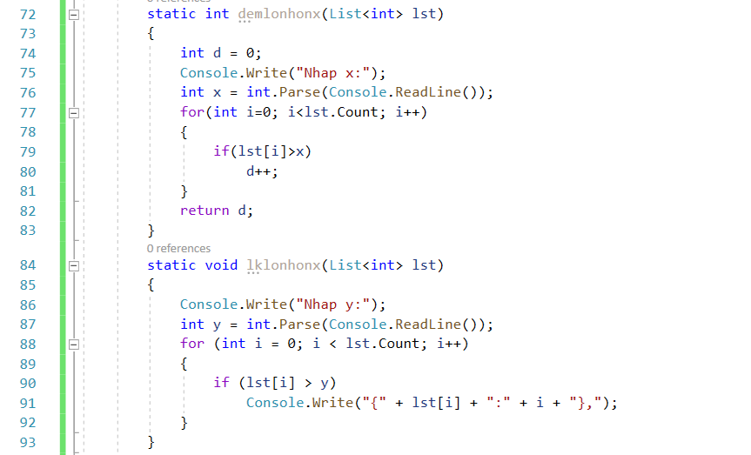

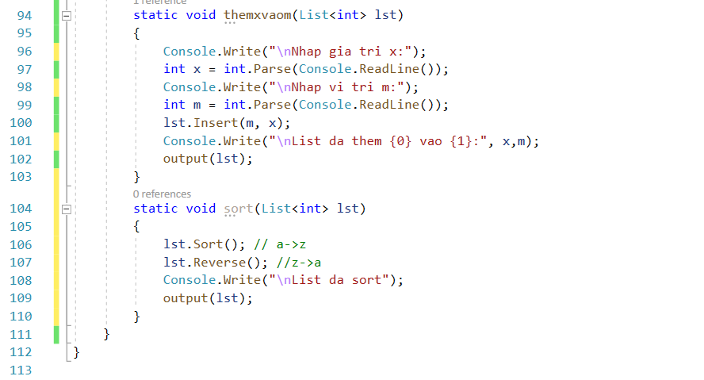

using System;

using System.Collections.Generic;

using System.Text;

namespace Bai_2

{

class ClassBaseEnemy

{

public readonly int id;

private readonly string name;

private float hp;

public float Hp { get => hp; set => hp = value; }

public string Name => name;

public ClassBaseEnemy()

{

}

public ClassBaseEnemy(int id, string name, float hp)

{

this.id = id;

this.name = name;

this.Hp = hp;

}

public void PrintEnemyInfo()

{

Console.WriteLine("{0}- {1} - {2}", id, Name, Hp);

}

public void input()

{

//Console.Write("Nhap id:");

//this.id = 5;// int.Parse(Console.ReadLine());

}

}

}